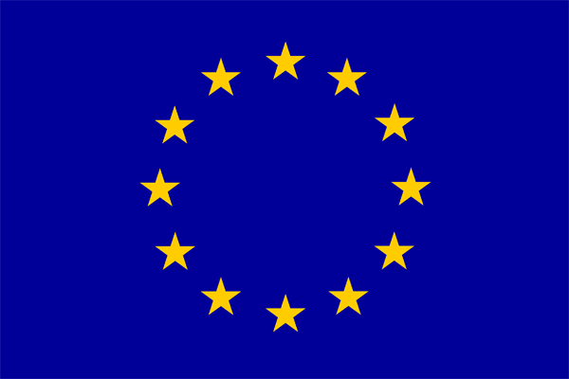

Program | Steering committee
Marine Station, Dinard, December 10th 2019

Steering committee | 9:30 - 10:45
9:00 – Coffee/tea of welcome
9:30 – 9:35 – Meeting start
9:40 – 10:10 – WP M – Management (Leader ESITC)
10:15 – 10:45 – WP C – Communication (Leader ESITC)

Coffee/tea break of 15 minutes

Technical committee | 11:00 – 17:00
11:00 – 12: 00 WP T1 – Pilot Operation: Biomimetic MI to create a specific habitat (Leader US)
Activity T1.1 Working group (US, UC)
Activity T1.2 Development and optimisation (ESITC)
Activity T1.3 Manufacturing and immersion (TPC, US)
Activity T1.4 Environmental monitoring (UC, US, ESITC, UE)
Activity T1.5 Business model (ESITC, UE, TPC, US)

Lunch break 12AM-1:30PM

13:30 – 16:30 – WP T2 – Biomimetic MI to improve the ecological status of the marine environment (Leader ESITC)

Activity | Moorings | Dykes | Rockpools
T2.1 Working group | ESITC, MNHN, UE | ESITC, UC, VCMF, TPC, PNA, UE | ESITC, PNA, BU, UC, UE
T2.2 Design and development of materials | ESITC, MNHN | ESITC, UC, UE | ESITC
T2.3 Manufacturing and immersion | ESITC, MNHN | TPC, PNA, VCMF | PNA, BU
T2.4 Development of indicators and environmental monitoring | MNHN | UC | UC, BU
T2.5 Business model | MNHN, ESITC, UE | UC, ESITC, UE, TPC | UC, BU, ESITC, UE

16:30 – 17:00 – WP T3 – Professional network (Responsible BU)
Activity T3.1 Quaterly synthesis (BU, CIRIA)
Activity T3.2 Network events
Activity T3.3 Professional trainings
Activity T3.4 Project result transfer

