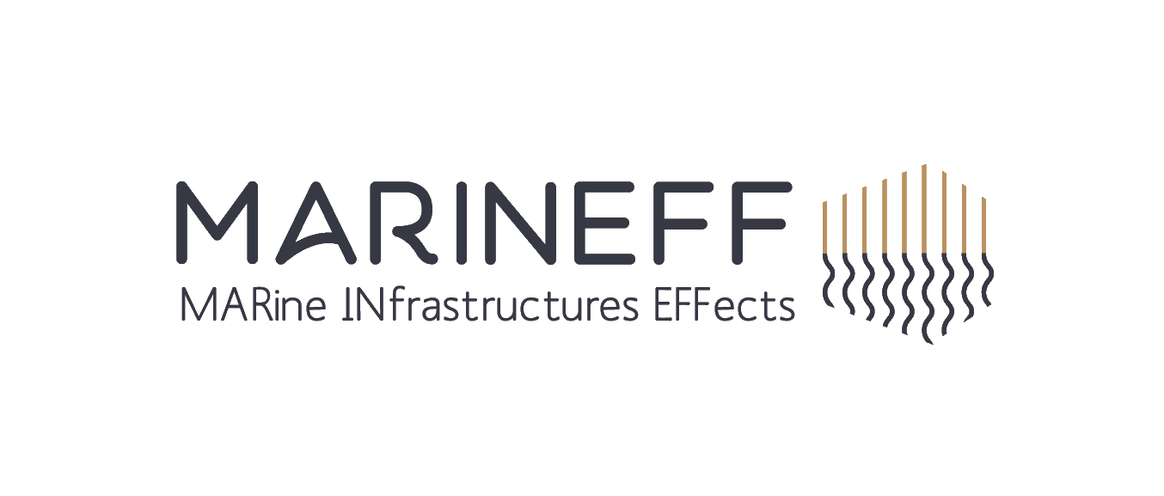
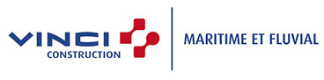
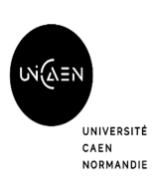
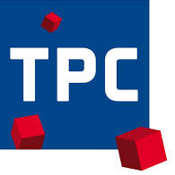

Press release

MARINEFF project: immersion of the first maritime biomimetic infrastructures in France and England

Monday, September 21st, 2020 - Launched in 2018 for a period of 4 years, the Interreg MARINEFF program intends to rethink marine infrastructures and design dikes, piers, quays, groins and moorings to better protect threatened ecosystems on both sides of the Channel. The efforts deployed by French and English industrial, port and universities, working together with ESITC Caen teams, have resulted in the launch of various prototypes adapted to the preservation of fishery resources and marine biodiversity.
ESITC Caen coordinates and manages the project and brings all the expertise of its research laboratory to bear in the field of maritime infrastructure - and in particular eco-designed concrete materials adapted to the marine environment - a theme that is integrated into the school's engineering training and the Specialized Master's degree in "Expert in Maritime and Port Structures". The school also has a unique experience, having piloted from 2011 to 2015, the Interreg IVA France (Channel) / England RECIF program which led to the construction of several artificial reefs immersed in the bay of Cherbourg. With a budget of 4.6 M€, co-financed by the ERDF (European Regional Development Fund), the MARINEFF project brings together French and British partners: ESITC Caen (project leader), University of Caen Normandy, National Museum of Natural History, Ports of Normandy, Travaux Public du Cotentin, VINCI Construction Maritime et Fluvial, University of Southampton, Bournemouth University and University of Exeter.

Objective: to improve the ecological status of water

After having identified the eight deployment sites with the required conditions (salinity, depth, type of seabed) and obtained authorizations from landowners, port and administrative authorities and all parties concerned, the project partners today submerged the marine biomimetic infrastructures in Cherbourg in Normandy. Resulting from a multidisciplinary approach covering construction, marine biology and ecology, these facilities aim to improve the ecological status of the waters by at least 15%. Regular monitoring will precisely measure their contribution based on the measurement of biomass, biodiversity, abundance of fishery resources and eutrophication, the monitoring of invasive species and the analysis of food webs.

Artificial moorings immersed off Dinard
These facilities, designed by ESITC Caen for dive boats, will compensate for the lack of fixed moorings on the famous dive sites in the Bay of Dinard, Bizeux, Buharats and Vieux-Banc. The infrastructures imagined in the framework of the MARINEFF project reduce the impact of the anchors dropped by the diving boats on the biodiversity of the natural reefs and provide support for the development of biodiversity.

Rockpools on the Ouistreham dike
The Normandy site was chosen along with the English sites of Poole Harbour and Bouldnor to host the artificial version of "rockpools", pools of stagnant water that form in rocky or muddy cavities after the passage of the tides. The structures will be installed to allow marine biologists from the University of Caen Normandy to study the effect of the distance between the rockpools on the colonization of the surrounding wall and the pools themselves.
Dike modules in Cherbourg and Bernières-sur-mer
The manufacturing of the 36 blocks of 120 cm side length, 24 of which are intended to reinforce the dikes of Cherbourg, started on March 5 at the port by the company TPC, a subsidiary of the VINCI group. Twelve of these elements will be deployed near the submerged artificial reefs in 2015 as part of the RECIF project piloted by ESITC Caen, which has since been colonized by marine flora and fauna (algae, crabs, fish) and studied in detail by biologists from the University of Caen Normandy. The twelve others will be placed along the eastern dyke. These infrastructures use an optimized design to increase biodiversity.
Oyster prism modules
Also produced by the local company in Normandy TPC, the oyster prism modules designed by the MARINEFF program partners will be deployed in the Solent, a strait separating the Isle of Wight from the United Kingdom mainland. Once the largest native oyster fishing area, the Solent has seen its production plummet since the 1980s due to increasing mortality from disease, declining water quality and overfishing. Optimized to promote oyster larvae attachment, the twenty-six modules will be immersed in shallow water, in the heart of the historic habitat of the native Solent oyster. These infrastructures use innovative ecomaterials, notably through the incorporation of shellfish by-products into the concrete, a formulation developed for the RECIF project.

For more information about the project and the partners:

http://marineff-project.eu/en/partners/project-partners/

Press Accreditation

ESITC Caen, Marie-Caroline Coubé : 06 08 75 27 80 – communication@esitc-caen.fr
Green Lemon, Laurence Le Masle : 06 13 56 23 98 l.lemasle@greenlemoncommunication.com

